A

MINI PROJECT REPORT

ON

**“TechNow**

**(Technical News and Debate Website)”**

Submitted in partial fulfillment of the requirement for the degree of

**BACHELOR OF TECHNOLOGY**

Submitted by

GROUP NO.'24'

**MR. ADITYA DINKAR MAGARE (2014BIT024)**

**MR. PRAFUL SHIVDAS JADHAV (2014BIT039)**

**MR. ROHAN DHARMANNA KHUL (2014BIT045)**

UNDER THE GUIDANCE OF

**Dr. A. J. Umbarkar**



DEPARTMENT OF INFORMATION TECHNOLOGY

**WALCHAND COLLEGE OF ENGINEERING, SANGLI**

**(An Autonomous Institute)**

**2016-2017**

**CERTIFICATE**



This is to certify that the mini project work entitled

**“TechNow**

**(Technical News and Debate Website)”**

Submitted by

.

**MR. ADITYA DINKAR MAGARE (2014BIT024)**

**MR. PRAFUL SHIVDAS JADHAV (2014BIT039)**

**MR. ROHAN DHARMANNA KHUL (2014BIT045)**

.

This project report is a record of student's own work carried out by him during the academic year 2016-2017, as per the curriculum laid down by

Walchand College of Engineering, Sangli

Dr. A. J. Umbarkar Dr. S. P. Sonavane

(Guide) (H.O.D.)

**Declaration**

We, the undersigned, hereby declare that the Project entitled **“TECHNOW (A Technical Website) "** submitted by us to Walchand College of Engineering, Sangli, under the guidance of **Dr. A. J. Umbarkar** is our original work. We further declare that, to the best of our knowledge and belief, this work has not been previously submitted to this or any other university.

|  |  |
| --- | --- |
| Date :  Place : | **Mr. Aditya D Magare**  **Mr. Praful S Jadhav**  **Mr. Rohan D Khul** |

**Acknowledgement**

We feel immense pleasure in submitting the Mini Project report entitled “**TECHNOW (A Technical Website)"**. We are thankful to our guide **Dr. A. J. Umbarkar** for their valuable guidance and kind help during implementing the Project and feel great to express our sincere gratitude to other all staff members of IT Department. We are also thankful to the Head of the 'Department of Information Technology' **Dr. S. P. Sonavane** for their valuable guidance during the implementation of Mini Project.

Acknowledged By,

**Mr. Aditya D Magare**

**Mr. Praful S Jadhav**

**Mr. Rohan D Khul**

# Abstract

Now a day’s information is the source of knowledge, and to enrich our knowledge we need information in the form of news, discussion, etc.

This website is based on news sharing among the people and the discussion on trending topics on people wants to talk.

This website contain two part one is news section in which people can share the news on the topic they are interested and other users can read on the same section posted by others. Second section contain debate, in this part users can start a debate on the topic they want debate with other people. Through debate we can know what other people thought about topic.

**Table of Content**

|  |  |
| --- | --- |
| 1. Introduction | ……...…...………………...……………………………..1 |
| 1. Use Case Diagram | ……...…...………………...……………………………..3 |
| 1. Sequence Diagram | ……...…...………………...……………………………..4 |
| 1. Project Terminology | ……...…...………………...……………………………..5 |
| 1. Web Technologies | ……...………………..….……………………………….8 |
| * 1. PHP | ……...…………...……………………………………….8 |
| * 1. Bootstrap | ……...…...………………...……………………………..9 |
| * 1. JavaScript | …….…...………………...……………………………..10 |
| * 1. AJAX | …….…...………………...……………………………..11 |
| 1. Database | …….…...………………...……………………………..12 |
| * 1. Mongo dB | …….…...………………...……………………………..12 |
| 1. Applications | ……..……………………………..…………………….14 |
| 1. Conclusion | …….…...………………...……………………………..14 |
| 1. References | ………………………………………………………….14 |

# Introduction

In today’s world news are very important because they inform us whatever happening around the world. News can be social, technical and environmental but one common thing between them is they alert people.

**News** is information about current events. Journalists provide news through many different media based on word of mouth, printing, postal systems, broadcasting, electronic communication, and also on their own testimony, as witnesses of relevant events.

Common topics for news reports include war, government, politics, education, health, the environment, economy, business, and entertainment, as well as athletic events, quirky or unusual events. Government proclamations, concerning royal ceremonies, laws, taxes, public health, criminals, have been dubbed news since ancient times. News media is typically biased, by being selective in what stories to report.

Humans exhibit a nearly universal desire to learn and share news, which they satisfy by talking to each other and sharing information. Technological and social developments, often driven by government communication and espionage networks, have increased the speed with which news can spread, as well as influenced its content. The genre of news as we know it today is closely associated with the newspaper, which originated in China as a court bulletin and spread, with paper and printing press, to Europe.

**Debate** is contention in argument; strife, dissension, quarrelling, controversy; especially a formal discussion of subjects before a public assembly or legislature, in Parliament or in any deliberative assembly.

Logical consistency, factual accuracy and some degree of emotional appeal to the audience are elements in debating, where one side often prevails over the other party by presenting a superior "context" or framework of the issue. The outcome of a debate may depend upon consensus or some formal way of reaching a resolution, rather than objective facts. In a formal debating contest, there are rules for participants to discuss and decide on differences, within a framework defining how they will interact.

Debating is carried out in debating chambers and assemblies of various types to discuss matters and to make resolutions about action to be taken, often by voting. Deliberative bodies such as parliaments, legislative assemblies, and meetings of all sorts engage in debates. In particular, in parliamentary democracies a legislature debates and decides on new laws. Formal debates between candidates for elected office, such as the leaders’ debates, are sometimes held in democracies. Debating is also carried out for educational and recreational purposes, usually associated with educational establishments and debating societies. The major goal of the study of debate as a method or art is to develop the ability to debate rationally from either position with equal ease

So above ideas we have implemented in our project. We have seen many news website where user don’t have privilege to post the news. Also user cannot review the news. But In our website, we have given full privilege to user. We have develop user centric website. In this user can post news which they like. Also other user can review this news by liking, commenting on it. Also if user feel that news is abusive or wrong then user can report about it to remove from website.

Also this idea can be implemented in college campus means all students and teacher as a user can share the news.

Second idea we have implemented in this project is debate session. We all know that debate is informal discussion in which people share their different views about the subject and at last vote on it. We used this concept because if any person want to know about any topics then he have to meet people and get their views. But every time person cannot meet so he put topic online to get views. In this website, user have to add the topic of debate. Also he should mention two side of topic i.e. positive and negative. Also user should mention how much time he wants to put topic online. So in this time we are taking views of all other user with help of counting how many user are favored of the topic and argument. At the end we are showing which side win the debate by voting.

1. **Use Case Diagram**

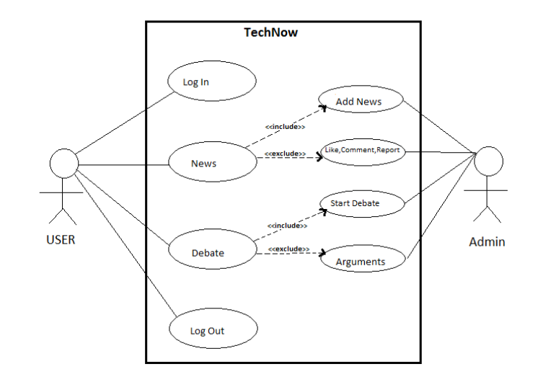

Fig 2.1 Use Case Diagram

1. **Sequence Diagram**

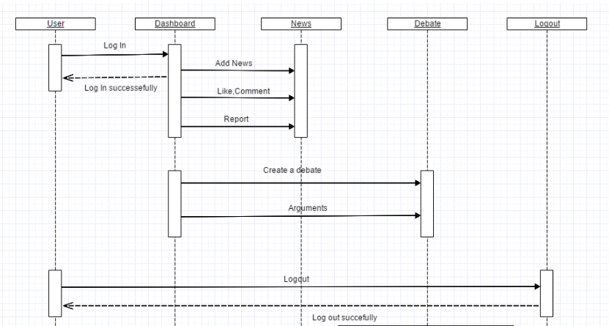

Fig 3.1 Sequence Diagram

1. **Project Terminology**

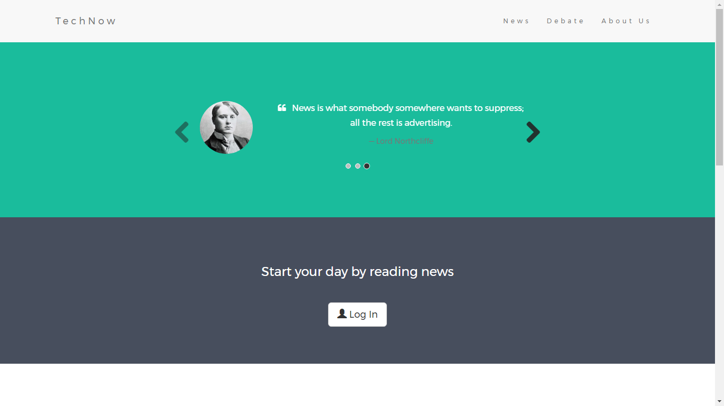

Fig 4.1 Home Page

This the main home page of website. For entering in the website first of all login to the website.

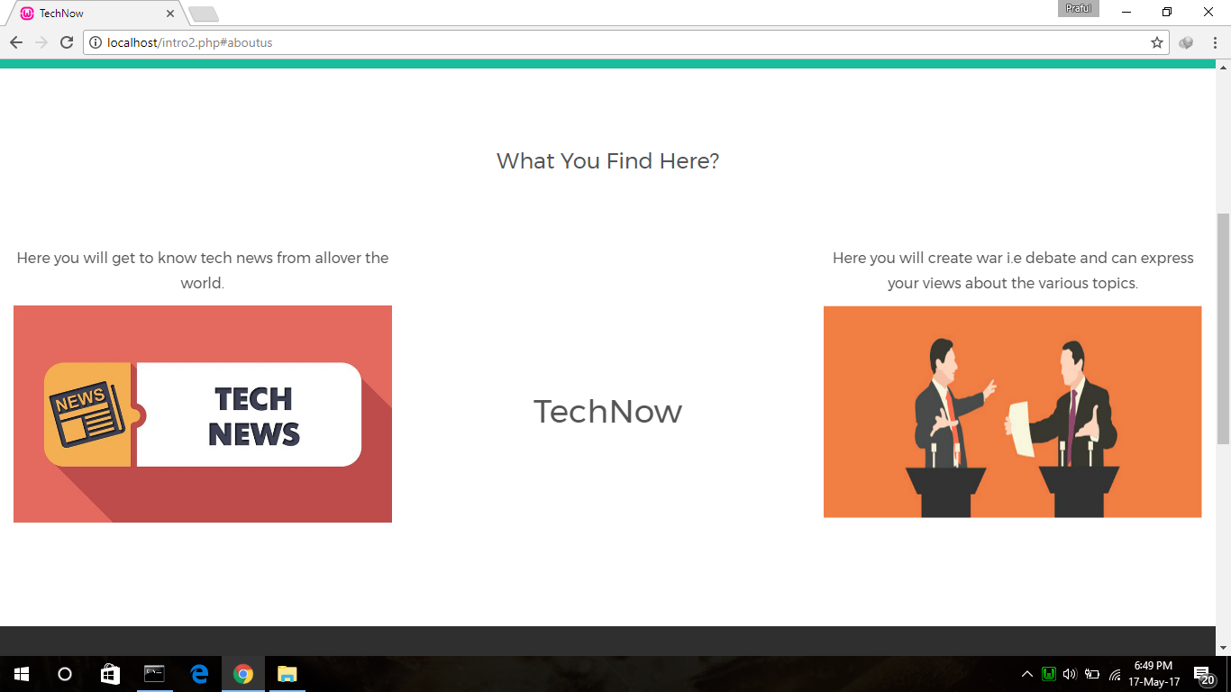

Fig 4.2 Home Page (2)

This is the home page of our website. It includes two sections one is Tech News and other is Debate session. User can select one of the two session by login to the website.

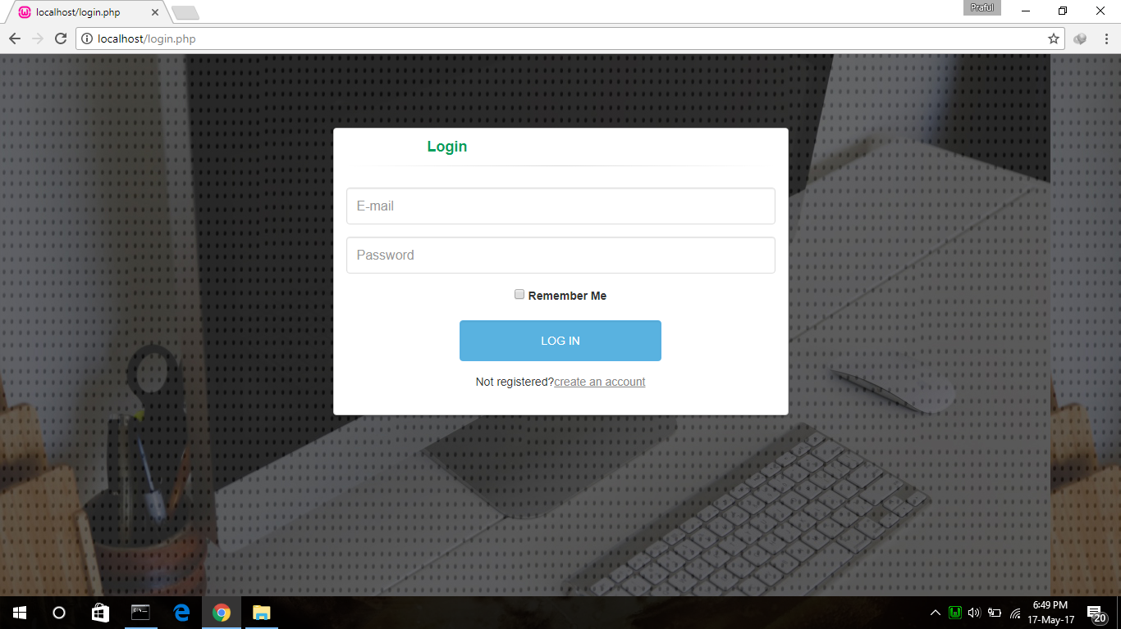

Fig 4.3 Login & Registration

In this user can register to the website by filling all his details like name, e-mail etc.

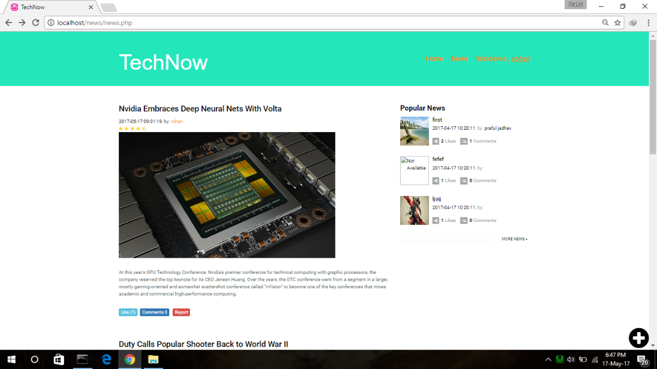

Fig 4.4. News Page

In this page user can read the news and user can also privilege to post news of any recent technical topic or campus news. Posted news will be verified by other user whether it is good or bad. In this page the popular news are listed according to most like.

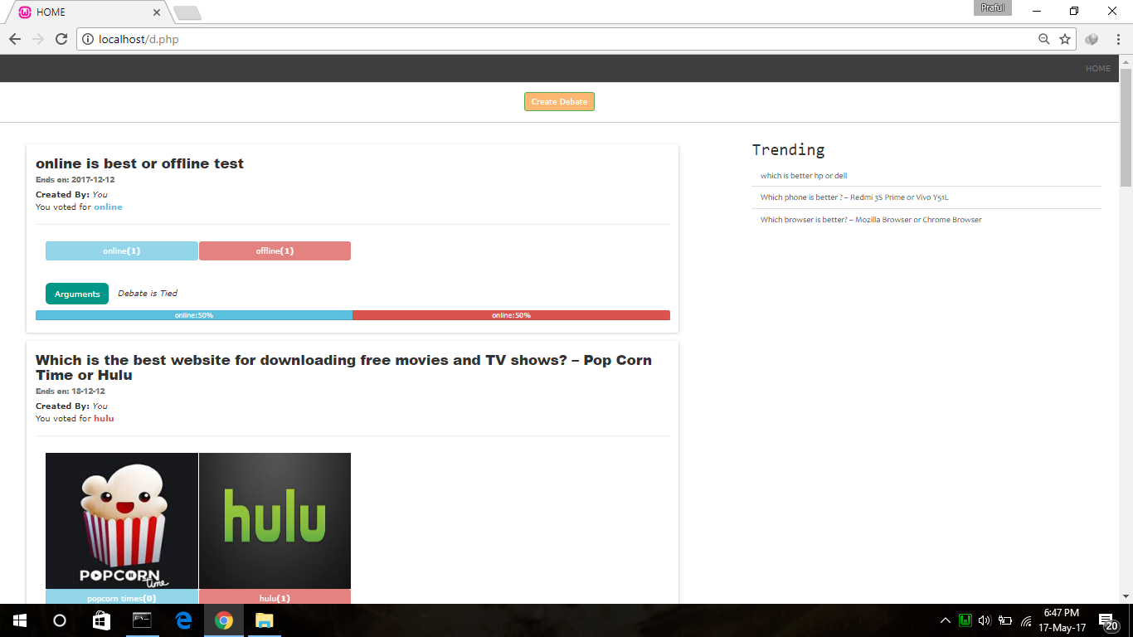

Fig 4.5. Debate Page

This section contains debate for trending news and topic. Here user can also create debate and also add images of respective topic on the both side and there is voting for each topic which decide most favored side of debate and topics are arrange according to the trending. One user can select or vote only one time and also he can give the arguments on topic which he voted.

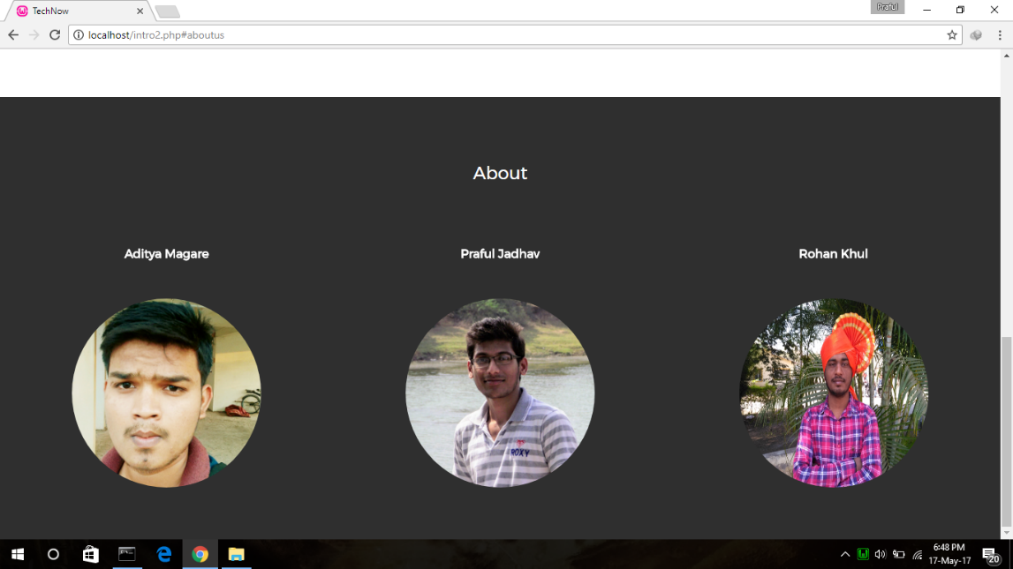

Fig 4.6. About Us

# Web Technologies

# PHP:

PHP is an HTML-embedded scripting language. Much of its syntax is borrowed from C, Java and Perl with a couple of unique PHP-specific features thrown in. The goal of the language is to allow web developers to write dynamically generated pages quickly.

PHP stands for PHP: Hypertext Preprocessor. This confuses many people because the first word of the acronym is the acronym. This type of acronym is called a recursive acronym.

One of the strongest and most significant features in PHP is its support for a wide range of databases. Writing a database-enabled web page is incredibly simple using one of the database specific extensions (e.g., for MySQL), or using an abstraction layer like PDO, or connect to any database supporting the Open Database Connection standard via the ODBC extension. Other databases may utilize URL or sockets, like Couch DB.

PHP also has support for talking to other services using protocols such as LDAP, IMAP, SNMP, NNTP, POP3, HTTP, COM (on Windows) and countless others. You can also open raw network sockets and interact using any other protocol. PHP has support for the WDDX complex data exchange between virtually all Web programming languages. Talking about interconnection, PHP has support for instantiation of Java objects and using them transparently as PHP objects.

PHP has useful text processing features, which includes the Perl compatible regular expressions (PCRE), and many extensions and tools to parse and access XML documents. PHP standardizes all of the XML extensions on the solid base of libxml2, and extends the feature set adding Simple XML, XML Reader and XML Writer support.

* 1. **BOOTSTRAP**

Bootstrap is a framework to help you design websites faster and easier. It includes HTML and CSS based design templates for typography, forms, buttons, tables, navigation, modals, image carousels, etc. It also gives you support for JavaScript plugins.

Bootstrap is responsive, mobile-first, prevailing, and front-end framework, which is developed along with CSS, JavaScript, and HTML. Bootstrap has many benefits from scratch for every web development project, and one such reason is the huge number of resources accessible for Bootstrap.

Every year mobile devices persist to grow hugely popular, and the requirement to have a responsive website has become compulsory and important too. As the fluid grid layout amends vigorously to the appropriate screen resolution, thus crafting a mobile-ready site is a smooth and easy task along with position, instead of vertically to exhibit accurately on mobile appliances.

One of the main benefits of utilizing Bootstrap happens to be the speed of the development. While driving out a new, fresh website or application swiftly, you should certainly reflect upon utilizing Bootstrap. Instead of coding from scrape, Bootstrap lets you to use ready-made coding blocks in order to assist you in setting up. You can blend that along with CSS-Less functionality and cross-browser compatibility that can give way to saving of ample hours of coding. You can even buy ready-made Bootstrap themes and alter them to fit your requirements, for gaining the quickest potential route.

# JavaScript

JavaScript is a lightweight, interpreted programming language. It is designed for creating network-centric applications. It is complimentary to and integrated with Java. JavaScript is very easy to implement because it is integrated with HTML. It is open and cross-platform.

JavaScript is a dynamic computer programming language. It is lightweight and most commonly used as a part of web pages, whose implementations allow client-side script to interact with the user and make dynamic pages. It is an interpreted programming language with object-oriented capabilities.

JavaScript was first known as LiveScript**,** but Netscape changed its name to JavaScript, possibly because of the excitement being generated by Java. JavaScript made its first appearance in Netscape 2.0 in 1995 with the name LiveScript. The general-purpose core of the language has been embedded in Netscape, Internet Explorer, and other web browsers.

**Advantages:**

* **Less server interaction** − you can validate user input before sending the page off to the server. This saves server traffic, which means less load on your server.
* **Immediate feedback to the visitors** − they don't have to wait for a page reload to see if they have forgotten to enter something.
* **Increased interactivity** − you can create interfaces that react when the user hovers over them with a mouse or activates them via the keyboard.
* **Richer interfaces** − you can use JavaScript to include such items as drag-and-drop components and sliders to give a Rich Interface to your site visitors.

JavaScript can be implemented using JavaScript statements that are placed within the **<script>... </script>** HTML tags in a web page. You can place the **<script>** tags, containing your JavaScript, anywhere within your web page, but it is normally recommended that you should keep it within the **<head>** tags. The <script> tag alerts the browser program to start interpreting all the text between these tags as a script.

# AJAX

AJAX, is a web development technique for creating interactive web applications. AJAX stands for **A**synchronous **Ja**vaScript and **X**ML. AJAX is a new technique for creating better, faster, and more interactive web applications with the help of XML, HTML, CSS, and Java Script.

Ajax uses XHTML for content, CSS for presentation, along with Document Object Model and JavaScript for dynamic content display.

Conventional web applications transmit information to and from the server using synchronous requests. It means you fill out a form, hit submit, and get directed to a new page with new information from the server.

With AJAX, when you hit submit, JavaScript will make a request to the server, interpret the results, and update the current screen. In the purest sense, the user would never know that anything was even transmitted to the server.

XML is commonly used as the format for receiving server data, although any format, including plain text, can be used.

AJAX is a web browser technology independent of web server software.

* AJAX is based on the following open standards:
* Browser-based presentation using HTML and Cascading Style Sheets (CSS).
* Data is stored in XML format and fetched from the server.
* Behind-the-scenes data fetches using XMLHttpRequest objects in the browser.
* JavaScript to make everything happen

# MongoDB

MongoDB is an open-source document database and leading NoSQL database. MongoDB is written in C++. MongoDB is a cross-platform, document oriented database that provides, high performance, high availability, and easy scalability. MongoDB works on concept of collection and document.

**Advantages:**

* **Schema less** − MongoDB is a document database in which one collection holds different documents. Number of fields, content and size of the document can differ from one document to another.
* Structure of a single object is clear.
* No complex joins.
* Deep query-ability. MongoDB supports dynamic queries on documents using a document-based query language that's nearly as powerful as SQL.
* Tuning.
* **Ease of scale-out** − MongoDB is easy to scale.
* Conversion/mapping of application objects to database objects not needed.
* Uses internal memory for storing the (windowed) working set, enabling faster access of data.

**Uses:**

* **Document Oriented Storage** − Data is stored in the form of JSON style documents.
* Index on any attribute
* Replication and high availability
* Auto-sharing
* Rich queries
* Fast in-place updates
* Professional support by MongoDB

**Useful IN:**

* Big Data
* Content Management and Delivery
* Mobile and Social Infrastructure
* User Data Management
* Data Hub

# Applications

1. This website is very useful for student and teacher who want to share their views.
2. This website will reduces the communication difference among groups of people who want to discuss on some topic

# Conclusion

Using this website people can share their knowledge and debate on topics of their interest.

# References

* <http://php.net/manual/en/tutorial.php>
* <https://docs.mongodb.com/manual/tutorial/>
* <http://getbootstrap.com/getting-started/>
* <https://www.w3schools.com/default.asp>